**University of Engineering & Technology, Taxila**

**B.Sc. Computer Engineering**



**Database Management Systems**

**Lab Manual: 3**

**Name: Nimra Nasir**

**Roll No: 19-CP-35**

**Semester: 5th**

**Section: Alpha**

**Submitted To: Sir Shahid**

**Tasks:**

|  |  |  |  |  |
| --- | --- | --- | --- | --- |
| **Name** | **Reg_No** | **Courses** | **Course_Code** | **Offered_By** |
| Ali | 01 | DIP | 1001 | Mr. A |
| Basit | 02 | DBMS | 1002 | Mr. X |
| Akram | 03 | OS | 1003 | Mr. Y |
| Asad | 04 | DBMS | 1002 | Mr. X |
| Zeeshan | 05 | DIP | 1001 | Mr. A |
| Muneer | 06 | OS |  | Mr. Y |
| Shafqat | 07 | NM | 1004 | Mr. H |
| Ahsan | 08 | OS | 1003 | Mr. Y |
| Ikram | 09 | DIP |  | Mr. A |
| Hassan | 10 | DSP |  |  |

**For the above table perform the following tasks: -**

## Task 1:

* **Calculate the number of records for the 3rd, 4th and 5th column.**
* **Find distinct number of records for the Course Code=1002 as Total.**
* **Find number of students registered for the course DIP as Total Courses.**

**a)**

**Calculate the number of records for the 3rd, 4th and 5th column.**

**Source Code:**

CREATE TABLE PersonsLab3 (

Name varchar(255),

Reg_No int,

Courses varchar (255),

Courses_Code int,

Offered_By varchar(255)

);

select count(Courses) AS Column3 from PersonsLab3

select count(Courses_Code) AS Column4 from PersonsLab3

Select count(Offered_By) AS Column5 From PersonsLab3

insert into PersonsLab3 Values

('Ali',01,'DIP',1001,'Mr.A');

insert into PersonsLab3 Values

('Basit',02,'DBMS',1002,'Mr.X');

insert into PersonsLab3 Values

('Akram',03,'OS',1003,'Mr.Y');

insert into PersonsLab3 Values

('Asad',04,'DBMS',1002,'Mr.X');

insert into PersonsLab3 Values

('Zeeshan',05,'DIP',1001,'Mr.A');

insert into PersonsLab3 (Name, Reg_No, Courses,Offered_By)

values('Muneer',06,'OS','Mr.Y');

insert into PersonsLab3 Values

('Shafqat',07,'NM',1004,'Mr.H');

insert into PersonsLab3 Values

('Ahsan',08,'OS',1003,'Mr.Y');

insert into PersonsLab3 (Name, Reg_No, Courses,Offered_By)

values('Ikram',09,'DIP','Mr.A');

insert into PersonsLab3 (Name, Reg_No,Courses)

values('Hassan',10,'DSP');

Select * from PersonsLab3;

Delete from PersonsLab3

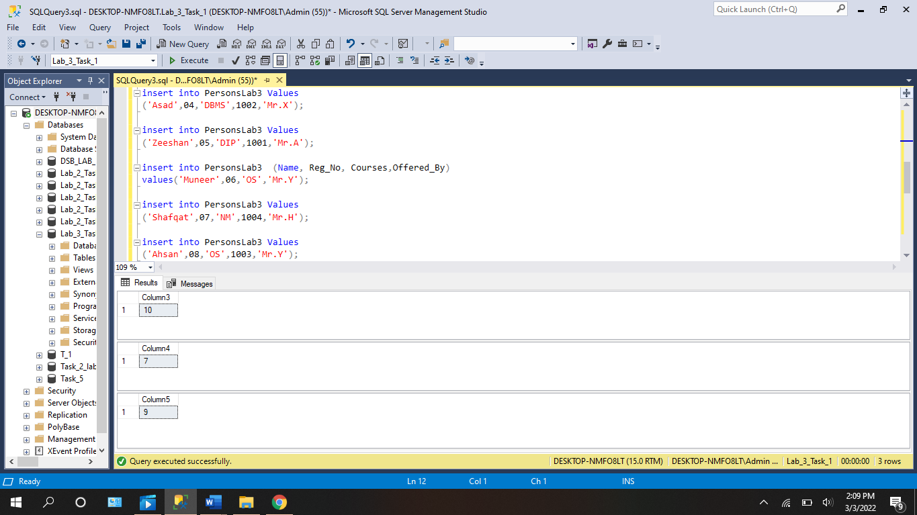

**b)**

**Find distinct number of records for the Course Code=1002 as Total.**

**Source Code:**

CREATE TABLE PersonsLab3 (

Name varchar(255),

Reg_No int,

Courses varchar (255),

Courses_Code int,

Offered_By varchar(255)

);

select count(Courses) AS Column3 from PersonsLab3

select count(Courses_Code) AS Column4 from PersonsLab3

Select count(Offered_By) AS Column5 From PersonsLab3

select count(*) as total from PersonsLab3

where Courses_Code = 1002

insert into PersonsLab3 Values

('Ali',01,'DIP',1001,'Mr.A');

insert into PersonsLab3 Values

('Basit',02,'DBMS',1002,'Mr.X');

insert into PersonsLab3 Values

('Akram',03,'OS',1003,'Mr.Y');

insert into PersonsLab3 Values

('Asad',04,'DBMS',1002,'Mr.X');

insert into PersonsLab3 Values

('Zeeshan',05,'DIP',1001,'Mr.A');

insert into PersonsLab3 (Name, Reg_No, Courses,Offered_By)

values('Muneer',06,'OS','Mr.Y');

insert into PersonsLab3 Values

('Shafqat',07,'NM',1004,'Mr.H');

insert into PersonsLab3 Values

('Ahsan',08,'OS',1003,'Mr.Y');

insert into PersonsLab3 (Name, Reg_No, Courses,Offered_By)

values('Ikram',09,'DIP','Mr.A');

insert into PersonsLab3 (Name, Reg_No,Courses)

values('Hassan',10,'DSP');

Select * from PersonsLab3;

Delete from PersonsLab3

**c)**

**Find number of students registered for the course DIP as Total Courses.**

**Source Code:**

CREATE TABLE PersonsLab3 (

Name varchar(255),

Reg_No int,

Courses varchar (255),

Courses_Code int,

Offered_By varchar(255)

);

select count(Courses) AS Column3 from PersonsLab3

select count(Courses_Code) AS Column4 from PersonsLab3

Select count(Offered_By) AS Column5 From PersonsLab3

select count(*) as total_Courses from PersonsLab3

where Courses = 'DIP'

insert into PersonsLab3 Values

('Ali',01,'DIP',1001,'Mr.A');

insert into PersonsLab3 Values

('Basit',02,'DBMS',1002,'Mr.X');

insert into PersonsLab3 Values

('Akram',03,'OS',1003,'Mr.Y');

insert into PersonsLab3 Values

('Asad',04,'DBMS',1002,'Mr.X');

insert into PersonsLab3 Values

('Zeeshan',05,'DIP',1001,'Mr.A');

insert into PersonsLab3 (Name, Reg_No, Courses,Offered_By)

values('Muneer',06,'OS','Mr.Y');

insert into PersonsLab3 Values

('Shafqat',07,'NM',1004,'Mr.H');

insert into PersonsLab3 Values

('Ahsan',08,'OS',1003,'Mr.Y');

insert into PersonsLab3 (Name, Reg_No, Courses,Offered_By)

values('Ikram',09,'DIP','Mr.A');

insert into PersonsLab3 (Name, Reg_No,Courses)

values('Hassan',10,'DSP');

Select * from PersonsLab3;

Delete from PersonsLab3

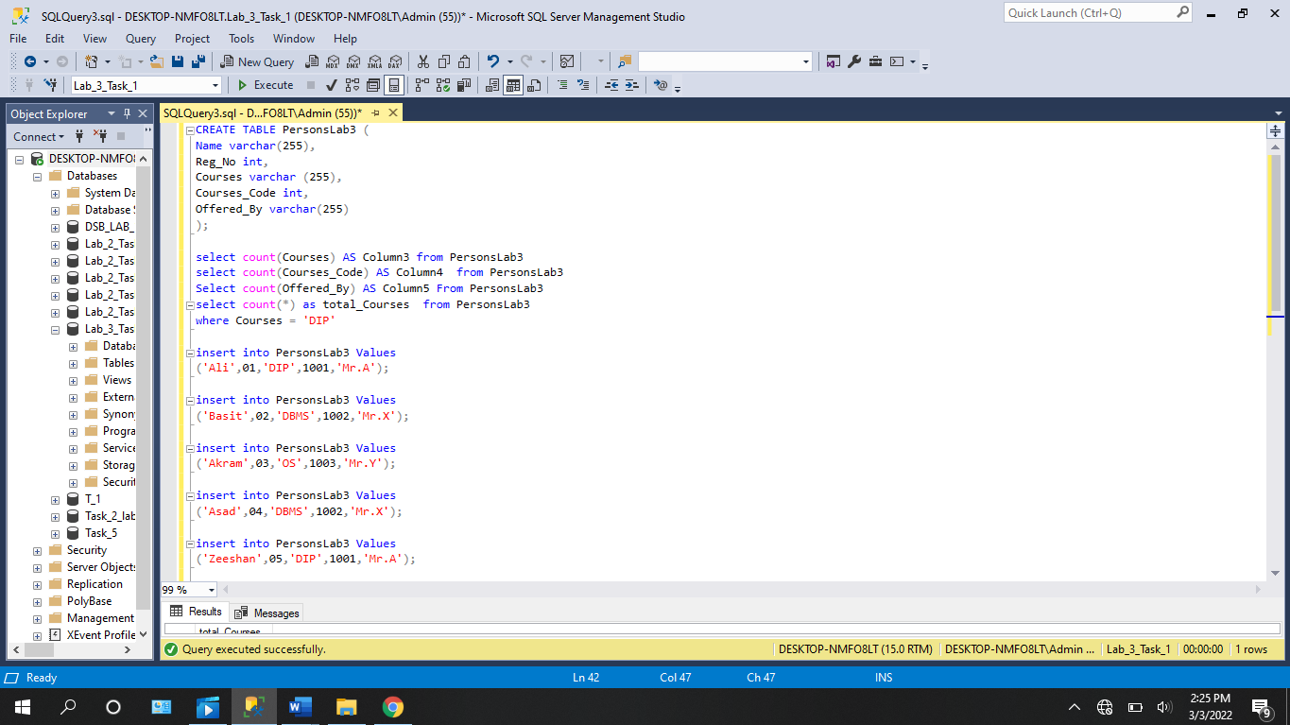

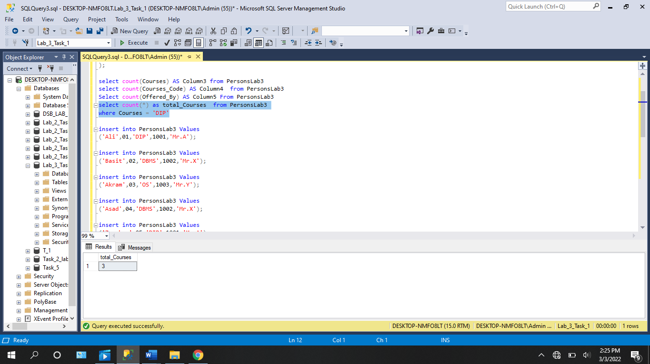

**Task: 2**

**Convert the text valued fields in the above table to the lower case and upper case alphabets.**

**Source Code:**

CREATE TABLE PersonsLab3 (

Name varchar(255),

Reg_No int,

Courses varchar (255),

Courses_Code int,

Offered_By varchar(255)

);

select count(Courses) AS Column3 from PersonsLab3

select count(Courses_Code) AS Column4 from PersonsLab3

Select count(Offered_By) AS Column5 From PersonsLab3

select count(*) as total_Courses from PersonsLab3

where Courses = 'DIP'

Select upper(Name) AS NAME from PersonsLab3

Select upper(Courses) AS COURSES from PersonsLab3

Select upper(Offered_By) AS OFFERED_BY from PersonsLab3

Select lower(Name) AS name from PersonsLab3

Select lower(Courses) AS courses from PersonsLab3

Select lower(Offered_By) AS offered_by from PersonsLab3

insert into PersonsLab3 Values

('Ali',01,'DIP',1001,'Mr.A');

insert into PersonsLab3 Values

('Basit',02,'DBMS',1002,'Mr.X');

insert into PersonsLab3 Values

('Akram',03,'OS',1003,'Mr.Y');

insert into PersonsLab3 Values

('Asad',04,'DBMS',1002,'Mr.X');

insert into PersonsLab3 Values

('Zeeshan',05,'DIP',1001,'Mr.A');

insert into PersonsLab3 (Name, Reg_No, Courses,Offered_By)

values('Muneer',06,'OS','Mr.Y');

insert into PersonsLab3 Values

('Shafqat',07,'NM',1004,'Mr.H');

insert into PersonsLab3 Values

('Ahsan',08,'OS',1003,'Mr.Y');

insert into PersonsLab3 (Name, Reg_No, Courses,Offered_By)

values('Ikram',09,'DIP','Mr.A');

insert into PersonsLab3 (Name, Reg_No,Courses)

values('Hassan',10,'DSP');

Select * from PersonsLab3;

Delete from PersonsLab3

**Task: 3**

**Using GROUP BY statement, group the courses for the above table.**

**Source Code:**

CREATE TABLE PersonsLab3 (

Name varchar(255),

Reg_No int,

Courses varchar (255),

Courses_Code int,

Offered_By varchar(255)

);

select count(Courses) AS Column3 from PersonsLab3

select count(Courses_Code) AS Column4 from PersonsLab3

Select count(Offered_By) AS Column5 From PersonsLab3

select count(*) as total_Courses from PersonsLab3

where Courses = 'DIP'

Select upper(Name) AS NAME from PersonsLab3

Select upper(Courses) AS COURSES from PersonsLab3

Select upper(Offered_By) AS OFFERED_BY from PersonsLab3

Select lower(Name) AS name from PersonsLab3

Select lower(Courses) AS courses from PersonsLab3

Select lower(Offered_By) AS offered_by from PersonsLab3

Select Courses from PersonsLab3 GROUP BY Courses

insert into PersonsLab3 Values

('Ali',01,'DIP',1001,'Mr.A');

insert into PersonsLab3 Values

('Basit',02,'DBMS',1002,'Mr.X');

insert into PersonsLab3 Values

('Akram',03,'OS',1003,'Mr.Y');

insert into PersonsLab3 Values

('Asad',04,'DBMS',1002,'Mr.X');

insert into PersonsLab3 Values

('Zeeshan',05,'DIP',1001,'Mr.A');

insert into PersonsLab3 (Name, Reg_No, Courses,Offered_By)

values('Muneer',06,'OS','Mr.Y');

insert into PersonsLab3 Values

('Shafqat',07,'NM',1004,'Mr.H');

insert into PersonsLab3 Values

('Ahsan',08,'OS',1003,'Mr.Y');

insert into PersonsLab3 (Name, Reg_No, Courses,Offered_By)

values('Ikram',09,'DIP','Mr.A');

insert into PersonsLab3 (Name, Reg_No,Courses)

values('Hassan',10,'DSP');

Select * from PersonsLab3;

delete from PersonsLab3

**Task: 4**

**Select maximum of the Reg no and smallest valued course code for the above given table.**

**Source Code:**

CREATE TABLE PersonsLab3 (

Name varchar(255),

Reg_No int,

Courses varchar (255),

Courses_Code int,

Offered_By varchar(255)

);

select count(Courses) AS Column3 from PersonsLab3

select count(Courses_Code) AS Column4 from PersonsLab3

Select count(Offered_By) AS Column5 From PersonsLab3

select count(*) as total_Courses from PersonsLab3

where Courses = 'DIP'

Select upper(Name) AS NAME from PersonsLab3

Select upper(Courses) AS COURSES from PersonsLab3

Select upper(Offered_By) AS OFFERED_BY from PersonsLab3

Select lower(Name) AS name from PersonsLab3

Select lower(Courses) AS courses from PersonsLab3

Select lower(Offered_By) AS offered_by from PersonsLab3

Select Courses from PersonsLab3 GROUP BY Courses

Select MAX(Reg_No) As MaximumValue from PersonsLab3

Select MIN(Courses_Code) As MinimumValue from PersonsLab3

insert into PersonsLab3 Values

('Ali',01,'DIP',1001,'Mr.A');

insert into PersonsLab3 Values

('Basit',02,'DBMS',1002,'Mr.X');

insert into PersonsLab3 Values

('Akram',03,'OS',1003,'Mr.Y');

insert into PersonsLab3 Values

('Asad',04,'DBMS',1002,'Mr.X');

insert into PersonsLab3 Values

('Zeeshan',05,'DIP',1001,'Mr.A');

insert into PersonsLab3 (Name, Reg_No, Courses,Offered_By)

values('Muneer',06,'OS','Mr.Y');

insert into PersonsLab3 Values

('Shafqat',07,'NM',1004,'Mr.H');

insert into PersonsLab3 Values

('Ahsan',08,'OS',1003,'Mr.Y');

insert into PersonsLab3 (Name, Reg_No, Courses,Offered_By)

values('Ikram',09,'DIP','Mr.A');

insert into PersonsLab3 (Name, Reg_No,Courses)

values('Hassan',10,'DSP');

Select * from PersonsLab3;

delete from PersonsLab3

**Task: 5**

**Find the length of each record for the first column in the above table as MAXIMUM LENGTH.**

**Source Code:**

CREATE TABLE PersonsLab3 (

Name varchar(255),

Reg_No int,

Courses varchar (255),

Courses_Code int,

Offered_By varchar(255)

);

select count(Courses) AS Column3 from PersonsLab3

select count(Courses_Code) AS Column4 from PersonsLab3

Select count(Offered_By) AS Column5 From PersonsLab3

select count(*) as total_Courses from PersonsLab3

where Courses = 'DIP'

Select upper(Name) AS NAME from PersonsLab3

Select upper(Courses) AS COURSES from PersonsLab3

Select upper(Offered_By) AS OFFERED_BY from PersonsLab3

Select lower(Name) AS name from PersonsLab3

Select lower(Courses) AS courses from PersonsLab3

Select lower(Offered_By) AS offered_by from PersonsLab3

Select Courses from PersonsLab3 GROUP BY Courses

Select MAX(Reg_No) As MaximumValue from PersonsLab3

Select MIN(Courses_Code) As MinimumValue from PersonsLab3

SELECT LEN(Name) as MAXIMUM_LENGTH FROM PersonsLab3

insert into PersonsLab3 Values

('Ali',01,'DIP',1001,'Mr.A');

insert into PersonsLab3 Values

('Basit',02,'DBMS',1002,'Mr.X');

insert into PersonsLab3 Values

('Akram',03,'OS',1003,'Mr.Y');

insert into PersonsLab3 Values

('Asad',04,'DBMS',1002,'Mr.X');

insert into PersonsLab3 Values

('Zeeshan',05,'DIP',1001,'Mr.A');

insert into PersonsLab3 (Name, Reg_No, Courses,Offered_By)

values('Muneer',06,'OS','Mr.Y');

insert into PersonsLab3 Values

('Shafqat',07,'NM',1004,'Mr.H');

insert into PersonsLab3 Values

('Ahsan',08,'OS',1003,'Mr.Y');

insert into PersonsLab3 (Name, Reg_No, Courses,Offered_By)

values('Ikram',09,'DIP','Mr.A');

insert into PersonsLab3 (Name, Reg_No,Courses)

values('Hassan',10,'DSP');

Select * from PersonsLab3;

delete from PersonsLab3

**Task: 6**

|  |  |  |  |
| --- | --- | --- | --- |
| **O_Id** | **OrderDate** | **OrderPrice** | **Customer** |
| 1 | 2008/11/12 | 1000 | Hansen |
| 2 | 2008/10/23 | 1600 | Nilsen |
| 3 | 2008/09/02 | 700 | Hansen |
| 4 | 2008/09/03 | 300 | Hansen |
| 5 | 2008/08/30 | 2000 | Jensen |
| 6 | 2008/10/04 | 100 | Nilsen |

**Find the average value for the 3rd column.**

**Source Code:**

CREATE TABLE LAB_3(

O_Id int ,

OrderDate varchar(30),

OrderPrice int ,

Customer varchar(30))

INSERT INTO LAB_3 VALUES(1, '2008-11-12', 1000, 'Hansen');

INSERT INTO LAB_3 VALUES(2, '2008-10-23', 1600, 'Nilsen');

INSERT INTO LAB_3 VALUES(3, '2008-09-02', 700, 'Hansen');

INSERT INTO LAB_3 VALUES(4, '2008-09-03', 300, 'Hansen');

INSERT INTO LAB_3 VALUES(5, '2008-08-30', 2000, 'Jensen');

INSERT INTO LAB_3 VALUES(6, '2008-10-04', 100, 'Nilsen');

select * from LAB_3

SELECT AVG(OrderPrice) AS OrderAverage FROM LAB_3

**Task: 7**

**Find if the customers "Hansen" or "Nilsen" have a total order of less than 2100 for the following table:**

|  |  |  |
| --- | --- | --- |
| **O_Id** | **OrderPrice** | **Customer** |
| 1 | 1000 | Hansen |
| 2 | 1600 | Nilsen |
| 3 | 700 | Hansen |
| 4 | 300 | Hansen |
| 5 | 2000 | Jensen |
| 6 | 100 | Nilsen |

**Also find if any customer have order of more than 1800.**

**Source Code:**

CREATE TABLE LAB_3(

O_Id int ,

OrderDate varchar(30),

OrderPrice int ,

Customer varchar(30))

INSERT INTO LAB_3 VALUES(1, '2008-11-12', 1000, 'Hansen');

INSERT INTO LAB_3 VALUES(2, '2008-10-23', 1600, 'Nilsen');

INSERT INTO LAB_3 VALUES(3, '2008-09-02', 700, 'Hansen');

INSERT INTO LAB_3 VALUES(4, '2008-09-03', 300, 'Hansen');

INSERT INTO LAB_3 VALUES(5, '2008-08-30', 2000, 'Jensen');

INSERT INTO LAB_3 VALUES(6, '2008-10-04', 100, 'Nilsen');

select * from LAB_3

SELECT AVG(OrderPrice) AS OrderAverage FROM LAB_3

SELECT Customer,SUM(OrderPrice) AS TotalSum FROM LAB_3

GROUP BY Customer;

SELECT Customer,SUM(OrderPrice) AS Sum_Less_than_2100 FROM LAB_3

WHERE Customer='Hansen' OR Customer='Nilsen'

GROUP BY Customer

HAVING SUM(OrderPrice)<2100;

SELECT Customer,SUM(OrderPrice) AS Sum_Greater_than_1800 FROM LAB_3

GROUP BY Customer HAVING SUM(OrderPrice)>1800;

DELETE FROM LAB_3

**Task: 8**

**Find the total sum (total order) of each customer.**

**Source Code:**

CREATE TABLE LAB_3(

O_Id int ,

OrderDate varchar(30),

OrderPrice int ,

Customer varchar(30))

INSERT INTO LAB_3 VALUES(1, '2008-11-12', 1000, 'Hansen');

INSERT INTO LAB_3 VALUES(2, '2008-10-23', 1600, 'Nilsen');

INSERT INTO LAB_3 VALUES(3, '2008-09-02', 700, 'Hansen');

INSERT INTO LAB_3 VALUES(4, '2008-09-03', 300, 'Hansen');

INSERT INTO LAB_3 VALUES(5, '2008-08-30', 2000, 'Jensen');

INSERT INTO LAB_3 VALUES(6, '2008-10-04', 100, 'Nilsen');

select * from LAB_3

SELECT AVG(OrderPrice) AS OrderAverage FROM LAB_3

SELECT Customer,SUM(OrderPrice) AS TotalSum FROM LAB_3

GROUP BY Customer;

DELETE FROM LAB_3

***--------------------------------------------------THE END-----------------------------------------------***